例如 ：实体如下图

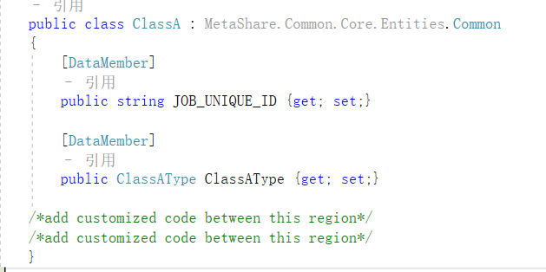

### CommonDao <T>

#### List<T> SelectBy(IContext context, T item, IList<string> byColumnNames);

1. List<ClassA> classAs = this.Dao.SelectBy(context, new ClassA { JOB_UNIQUE_ID = jobUniqueId }, new List<string> { "JOB_UNIQUE_ID" });
2. List<ClassA> items = this.SelectBy(pager,new ClassA { ClassAType = new MyTest2.Entities.ClassAType{ Id = classATypeId } },new List<string> { "ClassATypeId" });

#### List<T> SelectBy(IContext context, Expression<Func<T, bool>> expression);

1. List<ClassA> classAs1 = this.Dao.SelectBy(context, classA => classA.Name == "classA1" );
2. List<ClassA> classAs2 = this.Dao.SelectBy(context, classA => classA.Name.Contains("classA1") );
3. List<ClassA> classAs3 = this.Dao.SelectBy(context, classA => classA.ClassAType.Id == 1);

#### List<T> SelectBy(IContext context, Expression expression);